**AWS Free Tier**

The [AWS Free Tier](https://aws.amazon.com/free/) enables you to begin using certain services without having to worry about incurring costs for the specified period.

Three types of offers are available:

* Always Free
* 12 Months Free
* Trials

**Always Free**

* These offers do not expire and are available to all AWS customers.
* For example, AWS Lambda allows 1 million free requests and up to 3.2 million seconds of compute time per month. Amazon DynamoDB allows 25 GB of free storage per month.

**12 Months Free**

* These offers are free for 12 months following your initial sign-up date to AWS.
* Examples include specific amounts of Amazon S3 Standard Storage, thresholds for monthly hours of Amazon EC2 compute time, and amounts of Amazon CloudFront data transfer out.

**Trials**

* Short-term free trial offers start from the date you activate a particular service. The length of each trial might vary by number of days or the amount of usage in the service.
* For example, Amazon Inspector offers a 90-day free trial. Amazon Lightsail (a service that enables you to run virtual private servers) offers 750 free hours of usage over a 30-day period.

**How AWS pricing works**

AWS offers a range of cloud computing services with pay-as-you-go pricing.

* Pay for what you use**.**
* Pay less when you reserve.
* Pay less with volume-based discounts when you use more.

**AWS Pricing Calculator**

The AWS Pricing Calculator lets you explore AWS services and create an estimate for the cost of your use cases on AWS. You can organize your AWS estimates by groups that you define. A group can reflect how your company is organized, such as providing estimates by cost center.

**AWS pricing examples**

For AWS Lambda, you are charged based on the number of requests for your functions and the time that it takes for them to run.

* AWS Lambda allows 1 million free requests and up to 3.2 million seconds of compute time per month.
* You can save on AWS Lambda costs by signing up for Compute Savings Plans.

**Billing dashboard**

Use the [**AWS Billing & Cost Management dashboard**](https://docs.aws.amazon.com/awsaccountbilling/latest/aboutv2/billing-what-is.html) to pay your AWS bill, monitor your usage, and analyze and control your costs.

* Compare your current month-to-date balance with the previous month, and get a forecast of the next month based on current usage.
* View month-to-date spend by service.
* View Free Tier usage by service.
* Access Cost Explorer and create budgets.
* Purchase and manage Savings Plans.
* Publish [AWS Cost and Usage Reports](https://docs.aws.amazon.com/cur/latest/userguide/what-is-cur.html).

**Consolidated Billing**

The consolidated billing feature of AWS Organizations enables you to receive a single bill for all AWS accounts in your organization. By consolidating, you can easily track the combined costs of all the linked accounts in your organization. The default maximum number of accounts allowed for an organization is 4, but you can contact AWS Support to increase your quota, if needed.

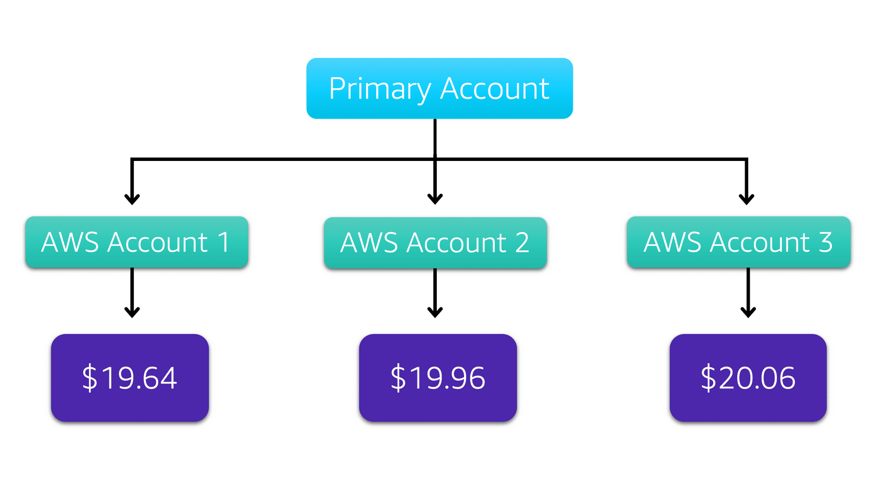

Suppose that you are the business leader who oversees your company’s AWS billing.

Your company has three AWS accounts used for separate departments. Instead of paying each location’s monthly bill separately, you decide to create an organization and add the three accounts.

You manage the organization through the primary account.

**AWS Budgets**

In [**AWS Budgets**](https://aws.amazon.com/aws-cost-management/aws-budgets), you can create budgets to plan your service usage, service costs, and instance reservations.

The information in AWS Budgets updates three times a day. This helps you to accurately determine how close your usage is to your budgeted amounts or to the AWS Free Tier limits.

In AWS Budgets, you can also set custom alerts when your usage exceeds (or is forecasted to exceed) the budgeted amount.

**AWS Cost Explorer**

[**AWS Cost Explorer**](https://aws.amazon.com/aws-cost-management/aws-cost-explorer/) is a tool that enables you to visualize, understand, and manage your AWS costs and usage over time.

AWS Cost Explorer includes a default report of the costs and usage for your top five cost-accruing AWS services. You can apply custom filters and groups to analyze your data. For example, you can view resource usage at the hourly level.

**AWS Support**

AWS offers four different [**Support plans**](https://aws.amazon.com/premiumsupport/plans/) to help you troubleshoot issues, lower costs, and efficiently use AWS services.

You can choose from the following Support plans to meet your company’s needs:

* Basic
* Developer
* Business
* Enterprise

**Technical Account Manager (TAM)**

The Enterprise Support plan includes access to a **Technical Account Manager (TAM)**.

If your company has an Enterprise Support plan, the TAM is your primary point of contact at AWS. They provide guidance, architectural reviews, and ongoing communication with your company as you plan, deploy, and optimize your applications.

**AWS Marketplace**

[**AWS Marketplace**](https://aws.amazon.com/marketplace) is a digital catalog that includes thousands of software listings from independent software vendors. You can use AWS Marketplace to find, test, and buy software that runs on AWS.

For each listing in AWS Marketplace, you can access detailed information on pricing options, available support, and reviews from other AWS customers.